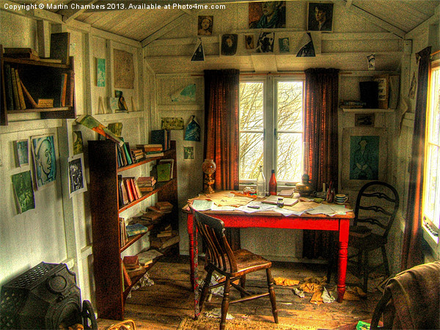

POEMS, PAINTINGS AND PLACES

THE DYLAN THOMAS CENTENARY

FRIDAY 25 TO MONDAY 28 JULY 2014
NICHOLAS FRIEND

I cared for the shapes of sound that their names made in my ears... for the colours the words cast on my eyes… Thomas stated to a reporter while on tour in the United States. This acclamation of the sensuality of words prompted one of my most powerful revelatory moments when an adolescent at school. Writing about him in my entrance exam helped to win me a place at Oxford, but when I arrived I was shocked to find that his work was scorned by the prim dons in the English department. Further injury was added to insult by my new, even more self-conscious, friends who proclaimed that Thomas was, ‘not sufficiently avant-garde, therefore obviously superficial’. Undaunted, I set out to challenge their view when, in 1977 at the ripe age of 20, I gave a jejune lecture-performance to the Oxford Poetry Society extolling his unique skill and power as a poet; the audience appeared somewhat shaken by my earnest presentation; perhaps I converted a few!

Now, 37 years later, Thomas’ work has only deepened its allure for me as I have realised not just the beauties of his lyricism, but the profundity and the breadth of his humanity. Still underestimated these years on, it is as though the ringing musicality of his work, along with his reputation for drunkenness, embarrass. Yet the sheer generosity of his vision and humour, whether writing of people or places, coupled with his intellectual control, mark him as functioning in that rare dimension where intellect is heightened by emotion. Cyril Connolly began by despising Thomas and ended by worshipping him. Philip Larkin said he was ‘a hell of a fine man.’ Toynbee named him ‘greatest living poet’. Alfred Kazin said of him that he ‘embodied the deepest cry of poetry’. It was Dylan Thomas who inspired John Lennon to write songs, Pinter to include poetry in his plays, and put the Dylan into Bob. Though some mocked him as a ’tubby little Welshman’, he was actually ‘the force that through the green fuse drives the flower’, a giant of a man. Amongst many other insights he was one of the first to recognise the huge cultural potential of radio and TV. This INSCAPE celebration of Thomas in his centenary year in Wales seeks to bring him closer to those of us who need no convincing as well as to those who may have missed him.

We go to Wales because Dylan Thomas cannot be understood without reference to the Welsh landscape and sea which nurtured his poetic vision. We honour him with a private visit and special lunch in his suburban birthplace in Swansea; in the Boat House at Laugharne, his dramatic home jutting out into the estuary, “My seashaken house / On a breakneck of rocks”; and, again, outside his tiny blue writing hut on the Taf estuary; and with a drink and a meal in his favourite Browns Hotel. Each morning amongst the paintings and comfort of the lovely Grove Hotel in Pembrokeshire, lectures, readings and recordings will set his work in the context of earlier and current melodious Anglo-Welsh poetry and prepare us for afternoon visits to Thomas’ own magical places: Fern Hill, Llansteffan, Llangain, Laugharne, New Quay and St Johns Hill.

FRIDAY 25 JULY
11:40 Meet Nicholas Friend at Swansea Station
12:00 Private lunch at Cwmdonkin Drive, Dylan’s birthplace
14:00 Visit Dylan Thomas Centre, Swansea for Dylan Thomas manuscripts
15:30 Leave for Hotel
16:30 Arrive Grove Hotel
19:30 Group Dinner at The Grove Hotel
SATURDAY 26 JULY
09:30 Lecture by Nicholas Friend
11:00 Leave for New Quay
12:00 Arrive New Quay, where Thomas wrote his finest poems
12:30 Lunch at Bosuns Locker
14:00 Leave for Aberystwyth
14:30 Arrive Aberystwyth National Library of Wales
17:00 Leave Aberystwyth National Library of Wales
18:30 Arrive Grove Hotel
20:00 Group Dinner at The Grove Hotel
SUNDAY 27 JULY
09:30 Lecture by Nicholas Friend
12:00 Leave for Laugharne
12:30 Lunch at Browns Hotel Restaurant
14:00 St Martins Church for Dylan’s and Caitlin’s graves, walk through Castle House gardens
14:30 Visit The Boathouse and Thomas’ writing shed
16:00 Short walk along the cliff for view of St John’s Hill
17:00 Leave for Grove Hotel
17:30 Arrive hotel
19:30 Group Dinner at The Grove Hotel
21:00 Poetry reading by Gillian Clarke, National Poet of Wales 2008-2013 TBC

MONDAY 28 JULY
09:30 Check out from Hotel
10:00 Leave for Tenby- Augustus and Gwen John Museum
10:30 Arrive Tenby
12:00 Lunch at The Mooring
14:00 Fern Hill, Llangain, Llansteffan and Swansea
16:30 Trains from Swanseay o

HOTEL
THE GROVE HOTEL, NARBERTH, PEMBROKESHIRE (see following page)

COST £1190 members, £1250 non-members, Single Room Supplement £200, deposit £150 includes three nights in The Grove Hotel, all breakfasts, all dinners with wine, all lectures, all entrance fees, all coach travel during the tour, all gratuities, VAT. Excludes travel to/from Swansea.

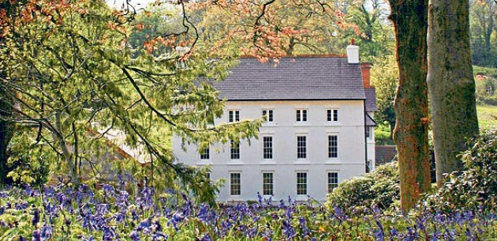

THE GROVE HOTEL
Molleston, Narberth, Dyfed

TEL 01834 860915
www.thegrove-narberth.co.uk
info@thegrove-narberth.co.uk

The Grove Hotel is that rare thing in Wales, a truly distinguished small historic hotel. A 15th century longhouse survives adjacent to the main house which was added to the property in the 1680s. Surrounded by 26 acres of trees, walled gardens and wildflower meadows, the three-storey dwelling was later extended by the Victorian architect John Pollard Seddon to include a grand hallway, staircase, drawing room, and library. Its rooms contain finely-detailed Gothic revival and Arts and Crafts fireplaces and panelling. Its award-winning restaurant, serves modern British food cooked by chef Duncan Barham with locally-sourced fresh meat and vegetables from its own kitchen garden.

Inscape CULTURAL STUDY SOCIETY
ST JUDE’S COTTAGE
12A CASTLEBAR HILL
LONDON, W5 1TD
020 8566 7539
info@inscapetours.co.uk

